CONFERENCE OF SPIRITUAL ASSISTANTS GENERAL
Nº 117 – 2023.1: ANNO 30
OFS – YOUFRA (CAS)
KOINONIA
… together on the journey

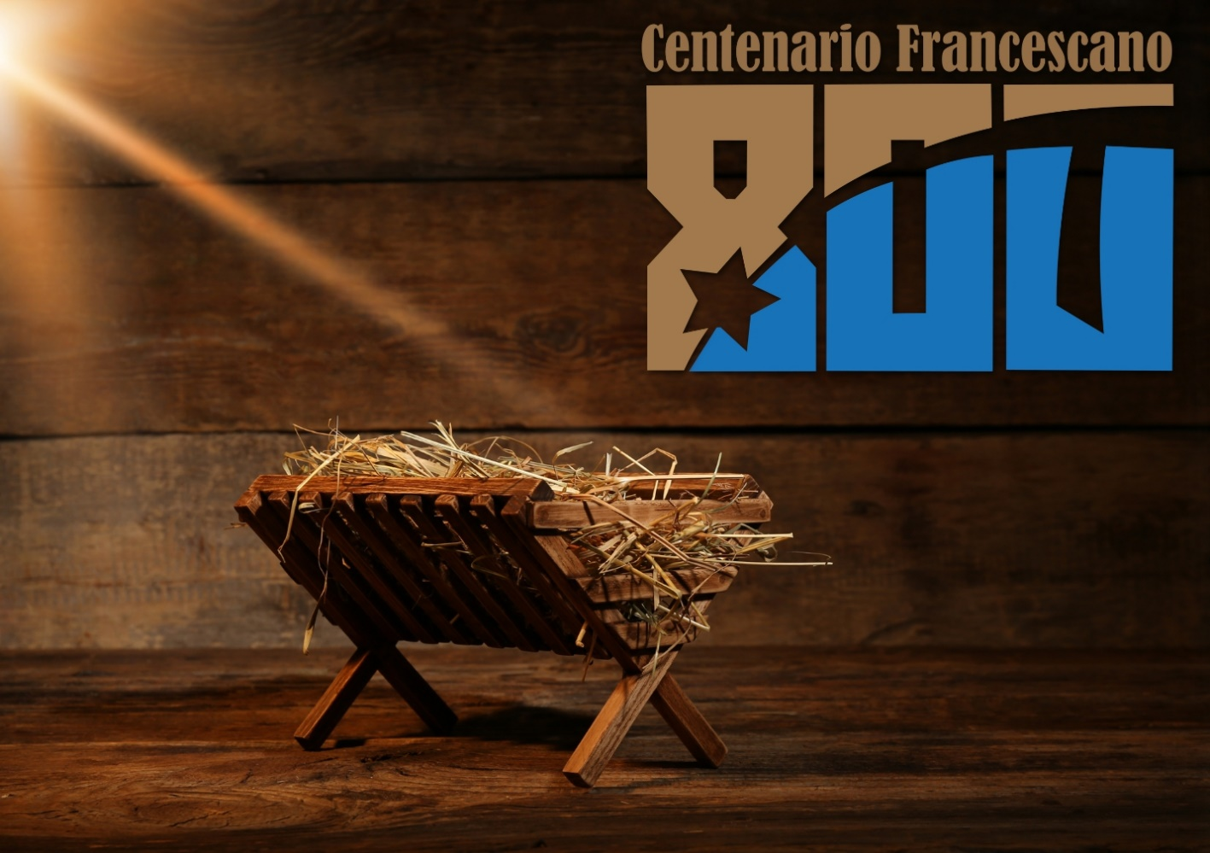
“ FRANCISCANS IN THE CELEBRATION OF JUBILEES”

THE RULE AT THE SERVICE OF THE CHARISM
Fr. Pedro Zitha, OFM

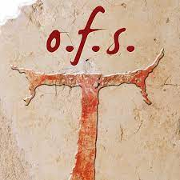
Introduction
A Rule of Life is absolutely indispensable for living one's vocation correctly, alone or with others. Through Christ, every person who wants to live the evangelical way of life is able to understand that life comes before the Rule, and the Rule serves as a reminder to focus on loving God and neighbour. The Rule is a tool to safeguard our freedom to love and live our lives according to the love of God and neighbour.
The Franciscan family will have the joy of celebrating the Franciscan Centenaries with various opportunities to enhance the gift of the Franciscan charism. The celebrations will be divided into several stages: in 2023, with the approval of the Regula Bullata and the Christmas in Greccio; in 2024, with the Stigmata, 2025 with the Canticle of Brother Sun and in 2026, with the passing away of St Francis. The Conference of Spiritual Assistants (CAS) decided to make its contribution by reflecting on several topics regarding the celebration of jubilees. For this year, the general theme is Franciscans in the Celebration of Jubilees divided into four subtitles: The Rule at the Service of the Charism; the Holy Gospel as a Rule of Life; the Meaning of the Crib in Today's World; the Nativity Scene in the Church. We hope that these themes will give energy to the Franciscan family at various levels and new paths of life to rediscover the joy and meaning of living the Franciscan charism today.

- The Gospel and the Franciscan Rule
The Franciscan Rule and that of the Secular Franciscan is to observe the Gospel way of life, even if called to different lifestyles, but all must "make present the charism of the Seraphic Father in the life and mission of the Church" and in the world in which they live. The life of St Francis of Assisi was an authentic example of a life inspired by the Gospel. His Rule of Life was nothing more than seeking God in everything he did and trying to live his vocation more effectively. His life was rooted in Scripture and always pointed to Christ.
A rule of life that one embraces during profession serves as a guide and is also meant to provide support as one continues to discern a personal relationship with God and others. A rule of life helps one to become a person of integral faith, and with the Gospel, the mind and heart are enlightened, guided and inspired to live the Charism, not for oneself but to contribute to the life of the church and society.
It is a rule of life inspired by the Gospel of Jesus Christ. This is what makes the SFO Rule totally different from any other rule of any government in this world, which is simply a set of explicit principles governing conduct in a particular sphere of activity.
The Gospel is the life, the truth and the way that every professed member is called to follow, or rather to live. Therefore, in order to profess and live one's vocation in a meaningful way according to the SFO Rule, "a true and assiduous reading of the Gospel" is necessary, allowing the Gospel to be not only the guide but a real and essential means for a correct understanding of the Rule.
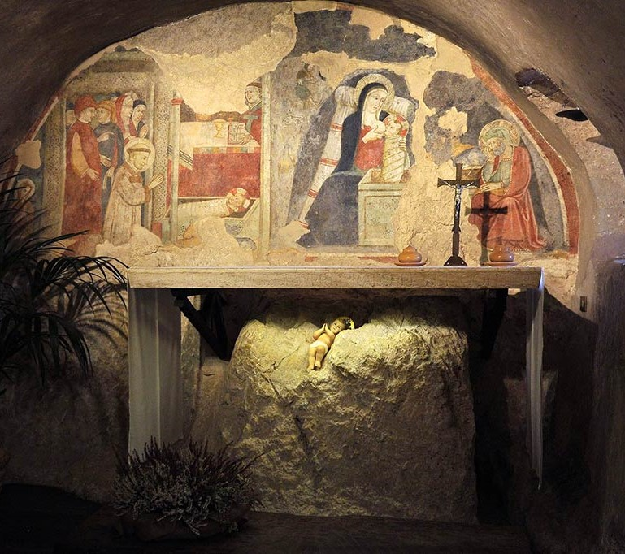
The Holy Scripture must always precede the Rule. St. Francis reading the Sacred Scriptures, was inspired to write a Rule of Life that then served as a key to a clear interpretation and understanding of the Sacred Scriptures. The Secular Franciscans, being bound by profession to live the Rule, are at the same time called to proclaim Christ by their lives and words, bearing witness to him in their mission in the world. "Let them be present with the witness of their human lives and also with courageous initiatives, both individual and communitarian, in the promotion of justice, and in particular, in the field of public life, committing themselves to concrete choices consistent with their faith". If the Rule and the life of a Franciscan is to observe the Gospel, their daily life must have Christ as the inspiration and centre of their life. When Christ is the model of life, the rule of life has more meaning and purpose. The goal of living the gospel will then be to witness to Christ in the world in which one lives and works. When the Gospel is embraced wholeheartedly, it can easily 'shape lives,' give direction and give purpose to vocation.

- The Franciscan Charism in the Church
Charism is a personal gift from God used for the good of the whole Church, for the world. The charism of St Francis of Assisi is simply to live the Gospel of Our Lord Jesus Christ. The Gospel becomes an essential reference point and the heart of every Franciscan as for all Christians.
The significance of charisms in the life of the Church is fundamental for the growth of its mission in the world. Charism should not be confined to a specific moment in the life of a Christian, but rather all charisms should be operative and allow the manifestation of the creativity of the Holy Spirit in the Church in any circumstance of life.
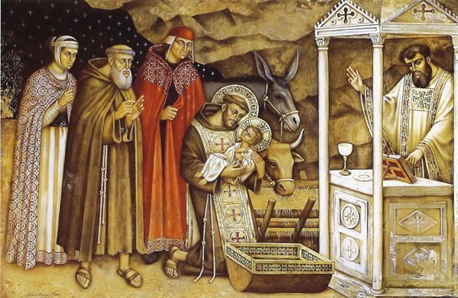
The Franciscan vocation is a personal call to live in fraternity and, at the same time to live that vocation in the Church and society. The Church expressed its joy during the approval of the Rule by saying: "We rejoice that the 'Franciscan charism' is still vigorous today for the good of the Church and the human community, despite the meandering of accommodating doctrines and the growth of tendencies that lead people away from God and supernatural things".
Undoubtedly, there are many daily challenges that every secular Franciscan has to face in this modern world that is very hostile to everything related to God and the teachings of the Church. Therefore, " You must be sincerely dedicated to that "high standard of ordinary Christian living" in order to better live the charism in the present without forgetting the origins, that is, the past, and at the same time planning for the future.
The question today should be: how is the Franciscan charism lived out in the Church and the world today? The answers must not only be heard but must be seen and experienced, especially by those who do not belong to the Franciscan family, because when the charism is well lived, it attracts others and gives joy and fulfilment to those who live it. The Franciscan charism must never be a theoretical thing because it is the very Gospel of Jesus who not only reveals his identity to us but offers himself to us so that we can be nourished, healed and brought to salvation. Therefore, those who profess the Franciscan Rule, both Seculars and members of the First Order and TOR, must make this Rule of life authentic, tangible and concrete so that all societies can experience God's Love through care and concern for the marginalised and the poor.
This, of course, requires a constant awareness of the specific gifts God has given us, according to the grace bestowed upon each one, intended to serve the entire body of the Church; the benefits of the gifts bestowed are intended for others because “in the common life, it is necessary that the power of the Holy Spirit, given to one, be transmitted to all. The one who lives for oneself, may have a charism, but it remains useless, hidden away inactive, because it remains buried within the self.”
The fraternal life that Franciscans embrace both in the First Order and the TOR, as well as for Secular Franciscans, allows each member to live the Franciscan charism in the fraternity, to share their gifts with the entire fraternity and society at large. As Christians and members of the Franciscan family, each person, regardless of age, "the manifestation of the Spirit is given to everyone for profit" (Lumen Gentium 12).

- The Relevance of the Rule in Today’s World
The Secular Franciscan Rule has been modified or updated several times and, on each occasion, has been relevant to the period and history of the Order. The Franciscan Charism is ancient and yet very relevant and appropriate to the times and circumstances, simply because its purpose is to live the Gospel way of life. It consists in living it with authenticity. It is actually everyone’s responsibility to make the Rule an expression of life, that of living the Gospel, consistent with everyday life and with a personal lifestyle capable of attracting others to follow in the same footsteps of Jesus through the example of Francis of Assisi.
Many penitents have been fascinated by the Franciscan Rule of Life, and each has always tried to live it in a way that explores new ways and forms of embracing the charism to make it more productive and effective for their own lives. No wonder the Secular Franciscan Order and the First Order, and TOR have grown in numbers. The question is: what has changed now? The answer is not so simple, but it is important to understand that each generation has its own ways of experiencing charisma, and people also have different ways of perceiving this charisma. However, in every circumstance and period of life, the Franciscan charism is to live the evangelical life since it has nothing but the Gospel, which requires a true witness, an experience of life and obliges a true proclamation of the good news lived and professed.
Therefore, it is not about the relevance of the charism itself but how those who have embraced this charism live it authentically in their families, convents, friaries, workplaces and society as a whole. The Second Vatican Council, through the Decree 'Perfectae Caritatis'(2), speaks of the adaptation and renewal of the religious life includes both the constant return to the sources of all Christian life and to the original spirit of the institutes and their adaptation to the changed conditions of our time. This renewal, under the inspiration of the Holy Spirit and the guidance of the Church, must be advanced according to the following principles:
a) Since the ultimate norm of the religious life is the following of Christ set forth in the Gospels, let this be held by all institutes as the highest rule.
b) ) It redounds to the good of the Church that institutes have their own particular characteristics and work. Therefore let their founders' spirit and special aims they set before them as well as their sound traditions-all of which make up the patrimony of each institute-be faithfully held in honor.
c) ) All institutes should share in the life of the Church, adapting as their own and implementing in accordance with their own characteristics the Church's undertakings and aims in matters biblical, liturgical, dogmatic, pastoral, ecumenical, missionary and social.
d) Institutes should promote among their members an adequate knowledge of the social conditions of the times they live in and of the needs of the Church. In such a way, judging current events wisely in the light of faith and burning with apostolic zeal, they may be able to assist men more effectively.
Each member of the SFO, like Saint Francis, is called to be a signal, to be a sure reference point for an integral Christianity lived in its fullness, without confining himself to the respective Order, Family and Church. Each member has his or her own way of living the Franciscan charism, his or her vocation and mission in the Church, but in this uniqueness, we are called to give life, to enter into the logic of the Gospel, that is, to realise in ourselves the mission of giving life to the Franciscan charism so that the world may find a living Christ in us.
Today's world is very visual; never content to hear without seeing. It is not enough to say that one belongs to the OFS or the Franciscan family; it is not enough to explain what the OFS or the Franciscans are. In the first place must be the testimony of life with the Word proclaimed with concrete and tangible facts. "Show me your faith without your works, and I will show you my faith by my works" (James 2:18).

Conclusion
Following a specific Rule of Life does not mean simply professing it but rather making a deep commitment, letting the seed of faith grow in one's life, learning to listen to and embrace Christ, and sharing the same Christ with others. Being Franciscan is nothing more and nothing less than integrating one's life into that of the Gospel, with its demands and joys. In both cases, it means that Christ must be the centre and the fulcrum because living the gospel means being part of Christ's love in all circumstances of life. A kind of love that brings a positive impact on the lives of others.
MEETINGS, PRESENCES AND CHAPTERS

Tempo Forte - Conference of Spiritual Assistants (CAS)
The members of the OFS Conference of General Spiritual Assistants met for the Tempo Forte in Palma de Mallorca, in the "San Francesco" convent of TOR, from 10-17 December 2022. Br. Tomas Ginga Suva, OFMCap. was unable to attend for study reasons (French language).
The work of the CAS began on Sunday, 10.12 at 9.00 a.m., following the planned agenda. In the afternoon, we had the opportunity to meet with Fr Manuel Romero, TOR Provincial Minister, at his residence in Porziuncola and discuss the topic of the OFS fraternities in Mallorca, the spiritual assistance offered to these fraternities, etc.
On Tuesday evening, we met the regional council of Balleares; it was a very positive meeting, and we were wonderfully surprised by their optimism and vivacity. The regional minister, Jordi, as well as the vice-minister, are young, full of hope, and they shared with us their dreams and hopes of strengthening the SFO and advancing GIFRA as well. The conversation ended with a fraternal agape offered by them in the convent.
On Wednesday, at 12 noon, we met with the spiritual assistants Br Carlos Enrique, OFM and Br Gil Pares OFMCap., who shared their work with us; then Br Jaime Puiserver, TOR, also arrived. The week was intense but also fruitful because we managed to achieve our objective.

Kenya- National Elective Chapter
The celebration of the elective national chapter of the OFS fraternity of Kenya was held from 08 to 11 December 2022 in Nakuru South Primary School. The referred chapter was presided over by the Councillor of the Presidency and responsible for the area, Sister Eremenciana CHINYAMA, OFS and assisted by the delegate of the Conference of General Spiritual Assistants, Fr. Emmanuel MASEREKA, OFMCap.
The chapter began in the evening of this same day, 8th December, with the celebration of Holy Mass, presided over by Fr. James WANZALA, OFMConv., national spiritual assistant, and concelebrated by Fr. Emmanuel MASEREKA, CAS delegate for this national chapter.
The election was conducted on 10 December, respecting the constitutional procedures and those of the National Statute in what concerns this act. Thus, the electoral act resulted in the election of the National Minister and the other members of the National Council. Brother Patrick KAMAU was elected National Minister and International Councillor at the same time.
In a general way, the chapter was celebrated in a fraternal atmosphere of openness and listening to the voice of the Holy Spirit, which favoured the acceptance of brothers to the various services of the National Council.

Singapore - National Elective Chapter
The national chapter of the emerging fraternity of Singapore was held on the 7th January 2023 at the Catholic Centre Singapore. The first part was presided by Janet Lim, the outgoing national minister, who at 9,30 welcomed all brothers and sisters.
The chapter began on Saturday, at 9,30. Janet Lim, the outgoing national minister, welcomed all brothers and sisters. After the reports were submitted, Fr. Derrick Yap, OFM, custos and national spiritual assistant, gave his spiritual presentation. Fr. Stefan Acatrinei, OFMConv, was also invited to motivate the assembly with spiritual encouragement. He pointed out the importance of embracing the cross given to us by God; that is, actually, the only one which better fits us.
The second part of chapter was presided by brother Francis Byungju Park, OFS presidency councillor, as the delegate of Tibor Kauser, minister general OFS, and Fra. Stefan Acatrinei, OFMConv, witnessed it. There were 21 capitulars and 11 observers. We also enjoyed the presence of two spiritual assistants: Sr. Victorine Fernandez, FMM and Br. Vernon Chua, OFM. The chapter proceeded beautifully, and the president gave some helpful advice. He accepted the nominees presented by the nominee committee and other names raised later from the floor.
Janet Lim was re-elected as a national minister and Jennifer Marie Suriyiacala as national vice minister. The whole national council, which was renewed, was installed during the Eucharistic celebration, presided by Fr. Derrick Yap. The homily was given by Fr. Stefan Acatrinei.
The national fraternity is still small, but its brothers and sisters are engaged in promoting OFS vocation, and the results can already be seen. The enchanting environment, which we all experienced, promises a lot for this emerging fraternity.

Tchad- National Chapter and Fraternal Pastoral Visit
From Tuesday 9th to Sunday 15th January 2023, we, Adolph Atsu ASSAGBA, CIOFS Presidency Councillor, and Br. Tomàs Ginga PANZO SUVA OFM Cap, representing the Conference of Spiritual Assistants, were in Chad at the request of the Minister General of the Secular Franciscan Order for the Fraternal and Pastoral Visit of the Secular Fraternity of Tchad, at the request of its National Council.
We mention that the last two (2) fraternal and pastoral visits took place in December 2013 and January 2020.
According to Article 94 of the General Constitutions of the Order Franciscan Secular (OFS), the fraternal visitation is a moment of communion, an expression of the service and concrete interest of secular leaders at different levels so that the fraternity grows in fidelity to its vocation. It was on this basis that we carried out the fraternal and pastoral visit, visiting almost all the local fraternities except those in the north, which due to the great distances, we were not able to do so.
On 14 January, the national elective chapter was held at the national headquarters in Moundou, where the National Minister - International Councillor and the new members of the national board for the three-year period 2023-2026 were elected. Thus, brother ANGE Gabriel was (re)elected National Minister and, at the same time International Councillor. The inauguration and closing mass of the Pastoral-Fraternal visitation and chapter was presided over by Fr Olivier, OFMcap., former national assistant, concelebrated by Fr Tomas Ginga Panzo Suva, OFMcap., general spiritual assistant, and Fr Marcel BOUMWASSI, OFMcap., current national assistant.

Malaysia – National Elective Chapter
The elective chapter of the national emerging fraternity from Malaysia was celebrated from 12th to 14th January 2023 at Tatal Retreat Centre, Keningau. Most of the brothers and sisters from East and West Malaysia arrived on Tuesday afternoon at the beautiful Retreat Centre.
The chapter was opened with the celebration of the Holy Eucharist at 6.00 pm and followed by dinner. Marina Anjuman, the outgoing national minister, gave her briefing at 8.00 pm, followed by the input given by the representative of CAS, Fr. Stefan Acatrinei, OFMConv. He pointed out the role of the OFS fraternity, namely, to carry out the task given by the Lord to St. Francis: to repair His Church in a challenging society. The first day concluded with the night prayer at 9.30 pm.
The second day started at 6.30 am with morning prayer, followed by breakfast. The national reports were presented from 9.00 am to 12.30 pm, followed by lunch.
The elective chapter was presided over by Francis Byungju Park, OFS presidency councillor for Asia-Oceania as the delegate of Tibor Kauser, minister general OFS, from 2.00 pm to 5.00 pm, and witnessed by Fr. Stefan Acatrinei. Sister Marina Anjuman was re-elected as a national minister, and brother Steven Joseph as national vice minister. The national council was partially renewed, and it was installed during the celebration of the Holy Eucharist.
A very beautiful program followed dinner from 8.00 pm to 9.30 pm and involved the whole assembly (40 capitulars and 26 observers). It really expressed Franciscan joy in an original way: singing, and dancing so that joy became visible, tangible and contagious. The second day concluded with night prayer at 9.30 pm.
Saturday, the third day, started with the celebration of the Holy Eucharist at 6.30 am, followed by breakfast.
The chapter was celebrated in a peaceful and joyful environment, which made many participants experience the presence of the Holy Spirit. Every single moment (prayer, breakfast, etc.) was prepared by a local fraternity.

Albania - National Elective Chapter
One day before the Chapter, in the OFM Convent of Shkodra, a fraternal meeting took place between the outgoing National Council with its National Assistant, Fr Valentin Tinaj, OFM, and the Delegate of the Minister General Tibor Kauser: Noemí Paola and the General Assistant, Fr Carlos Ginés, TOR.
On Saturday, 21 January 2023, the OFS National Chapter of Albania was celebrated in the city of Shkodra. The convent of the OFM Provincial Curia welcomed the 35 participants to the National Chapter. After the report of the outgoing National Minister and the outgoing National treasurer, questions and suggestions were posed. International Councillor Noemí Paola emphasised responsibility in accepted services and the importance of formation.
On Saturday afternoon, in the presence of the delegate of the OFS General Minister and the General Spiritual Assistant, the National Chapter elected by secret ballot Lazer Gega as National Minister and Vera Dedi as Vice-Minister to serve for the next three years. The Chapter was held in a spirit of joy, fraternity, and hope. The brothers and sisters gathered and gave thanks to God by sharing their faith in the Eucharist for the celebrated Chapter.

Rwanda- National Elective Chapter
On 26 January 2023 at 6,30 p.m. in the parish church of Kivumu, entrusted to the Friars Minor, where the OFS national headquarters in Rwanda is located, the Holy Mass was held for the opening of the elective national chapter of the above-mentioned OFS fraternity. The Eucharistic celebration was presided over by Fr Tomas Ginga Panzo SUVA, OFMcap., General Assistant, concelebrated by the National Assistant, Fr BISHYANUKA Joseph, OFM, and all the Secular Franciscan brothers and sisters delegated to this event were present.
On 28th January, the day of the election, the chapter was presided over by the International Councillor of the Presidency, Adolph Koku ASSAGBA, OFS, as the person in charge of the area and as the delegate of the Minister General Tibor Kauser, and assisted by Brother Tomas Ginga Panzo SUVA, OFMcap., as the representative of the Conference of Assistants General (CAS). The act of election resulted in choosing the National Minister and councillors. Thus, Brother HAFASHIMANA Valens was elected National Minister of the fraternity of Rwanda in the first ballot; he is also, according to the statutes of the fraternity of Rwanda, the International Councillor.
The Chapter was celebrated in an atmosphere of Franciscan serenity and joy and in accordance with the OFS General Constitution and the National Statute in force for this emerging fraternity. The closing Mass and inauguration of the new council were celebrated on the same Saturday at 6,30 p.m. in the parish church, feast of St Thomas Aquinas. The Holy Eucharist was presided over by the national assistant and concelebrated by the general assistant; all the capitulars attended it. There were also present some Friars Minor from the local fraternity of Kivumu.

German-Speaking Switzerland - Regional Elective Chapter
The Mattli Antoniushaus retreat centre, located in a picturesque place in Morschach, Canton Schwyz, hosted the regional elective chapter of German-speaking Switzerland on 4 February 2023. The chapter started at 5.30 p.m. with a greeting from Nadia Rudolf von Rohr, the outgoing regional minister. Then, the OFS Minister General Tibor Kauser presided over the chapter, and Fr. Stefan Acatrinei, OFMConv, CAS representative, offered a spiritual impulse.
There were 12 representatives of the ten local fraternities, namely the capitulars with voting rights, and 12 observers. The newly elected regional minister is Monika Bosshard. The new regional council was invested during the Eucharistic celebration presided over by the general spiritual assistant, Fr. Stefan Acatrinei.
The chapter ended with dinner. It was also an excellent opportunity for sharing among the brothers and sisters and lasted until around 10.00 p.m. It was a beautiful atmosphere, and many of them recounted with much nostalgia how they, too, contributed, as Yufra at that time, to the building of Mattli Antoniushaus, which was intended from the beginning to serve the needs of the young Franciscans.

Dominican Republic - National Elective Chapter
The National Elective Chapter of the Franciscan Order of the Dominican Republic was held with joy, fraternity, and faith, as indicated in the General Constitutions and National Statutes. The great feast of the National Chapter took place from 17 to 19 February at the Capuchin Friars' House. It began with the Eucharist presided over by Fr Freddy Leonardo, OFMcap, national Assistant and by Br Carlos Ginés, TOR, General Assistant. The OFM National Assistant was not present during the noted event. After a reflection on synodality by International Councillor Ana María Raffo, delegate of Minister General Tibor Kauser, OFS, the economic and governance reports of the outgoing National Council were read out. After an exchange of questions-answers and a sharing of ideas on the reports, they were approved. Election time began on the afternoon of Saturday 18, after a reflection given by Brother Carlos. After several votes, Altagracia Rodriguez was elected as National Minister and International Councillor. The days of the Chapter ended with great confidence and faith in God. The brothers and sisters returned to their homes with great joy, having spent some time together.

Uruguay- National Elective Chapter
The National Elective Chapter of Uruguay was held on the 4th and 5th March 2023 in the Monastery of the Capuchin Poor Clare Sisters of Echeverría in Canelones. Sister Matilde Beltrame was elected National Minister and International Councillor.
There are only seven local Fraternities in Uruguay. The Chapter was attended by 18 Chapter delegates and seven observers. An animator of fraternities was elected for the first time in the history of the OFSF in Uruguay. Therefore, it is a great joy to accept the challenge to start working to form YouFra fraternities in this country. The presence of the older sisters and brothers enriches our Order since they have travelled a long path of vocation and Franciscan service in this country. The fraternal and pastoral visitation, which began in 2019 (and interrupted due to the pandemic), was finally completed. The fraternities, though few, have a great desire to grow and continue their journey. They are also enjoying now the help of spiritual assistants.

CIOFS Presidency
The International Council of the Order Franciscan Secular (CIOFS) held its first annual meeting at the International College of Conventual Friars at Seraphicum from 18th to 25th March 2023. All members of the Presidency were present, except for Vice General Minister Mary Stronach and her husband, Robert Stronach, who were unable to attend due to health issues. Thank God, Mary has been able to join the Presidency virtually via Zoom for the past four days.
The first three days of the Presidency meeting were devoted to the spiritual and juridical formation, followed by training on the practical and technical issues of National Elective Chapters and fraternal and pastoral visits.
It was a very intense week of work. All Presidency Councilors and General Spiritual Assistants had to share their experience of working in different commissions and areas.
All members devoted the entire week to evaluating, reviewing, deciding and updating the various commissions and reports on the Legal Office; congresses; the Family Commission; the Gifra Commission; the Economic Commission; the Commission for the Cause of Saints; the Commission for Vocations Promotion; the XVII Intermediate General Chapter 9-14 November 2024 of CIOFS; final decisions on the possible realisation of a Chapter of Mats for the Secular Franciscan Order and Youfra to be held November 14-19,2024; Africa Project; Statute of the International Fraternity - Ad Experimentum; and national fraternity updates on fraternal and pastoral visits.
Finally, on Saturday, 25th March, the Presidency had the joy of concluding the long week of intense work and taking farewell as its members were preparing to return to their local fraternities in the four corners of the world.

OFS Rule 1
OFS Rule, n 15; Apostolicam Actuositatem, 14.
Cfr. Cf. Address of the Holy Father Francis to the participants at the General Chapter of the Order Franciscan Secular, Clementine Hall, Monday, 15 November 2021.
Apostolic Letter of Approval seraphicus patriarcha of Pope Paul VI ad perpetuam rei memoriam.
Address of John Paul II to the participants at the General Chapter of the Third Secular Franciscan Order, Friday, 22 November 2002 n. 4.
Congregation for the Doctrine of the Faith, Letter Iuvenescit Ecclesia to the Bishops of the Catholic Church on the Relationship between Hierarchical and Charismatic Gifts for the Life and Mission of the Church. n.5.

